Debugging Transformer Model with PyCharm and WSL

# Document Control

* **Document Title**: Transformer Model Debugging Analysis
* **Team**: [**Team 9**]
* **GitHub Rebo Link**: <https://github.com/nancy-abduallh/Assignment-1>
* **Project**: Debugging Transformer Models with PyCharm and WSL
* **Model**: Standard Encoder-Decoder Transformer (Vaswani et al., 2017)

# Executive Summary

This document provides a comprehensive analysis of the Transformer model's internal operations through systematic debugging using **PyCharm with WSL**. The debugging session captures 43 critical snapshots of tensor dimensions and values at each processing stage, demonstrating the complete data flow from input tokens to final output logits.

# 1. Environment Configuration

## 1.1 PyCharm WSL Setup

* **Python Interpreter**: WSL-based Python environment
* **Debugger Configuration**: PyCharm Professional with WSL integration
* **Dependencies**: PyTorch, NumPy, and standard deep learning libraries

## 1.2 **Model** Configuration

**Model Parameters:**

* **Embedding Dimension (d_model): 128**
* **Number of Attention Heads: 4**
* **Encoder Layers: 2**
* **Decoder Layers: 2**
* **Feed-Forward Dimension (d_ff): 512**
* **Vocabulary Size: 1000**

# 2. Input Data Specification

## 2.1 Source Sequence

* **Domain**: Programming/Coding
* **Sequence Length**: 8 tokens
* **Token IDs**: [100, 201, 302, 403, 504, 605, 706, 807]
* **Shape**: (8, 1) - (sequence_length, batch_size)

## 2.2 Target Sequence

* **Domain**: Programming/Coding (Translation/Generation)
* **Sequence Length**: 7 tokens
* **Token IDs**: [150, 251, 352, 453, 554, 655, 756]
* **Shape**: (7, 1) - (sequence_length, batch_size)

# 3. Detailed Snapshot Analysis

## 3.1 Input & Embedding Layer Snapshots (1-5)

### 3.1.1 Snapshot #1: Raw Input Tokens

* **Tensor Shape**: torch.Size([8, 1])
* **Values**: [100, 201, 302, 403, 504, 605, 706, 807]
* **Explanation**: Represents the source sequence token IDs before embedding lookup. The shape (8, 1) indicates 8 tokens in a batch of size 1.

* **Tensor Shape**: torch.Size([7, 1])
* **Values**: [150, 251, 352, 453, 554, 655, 756]
* 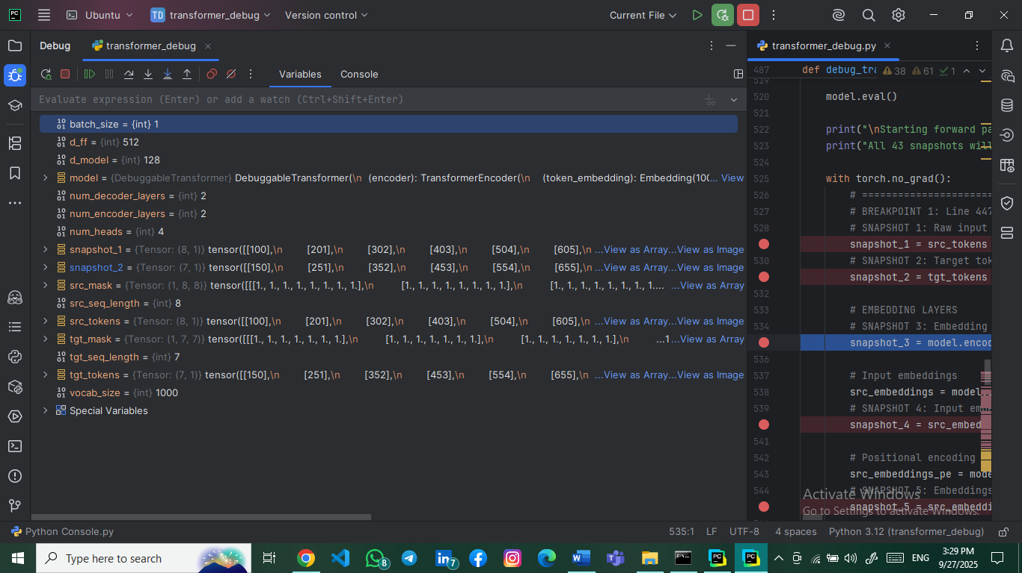**Explanation**: Target sequence token IDs for training/decoding. The shorter length (7 vs 8) demonstrates handling of variable-length sequences.

### 3.1.3 Snapshot #3: Embedding Weight Matrix (Slice)

* **Tensor Shape**: torch.Size([5, 5])
* **Values**: 5×5 slice of the embedding matrix
* 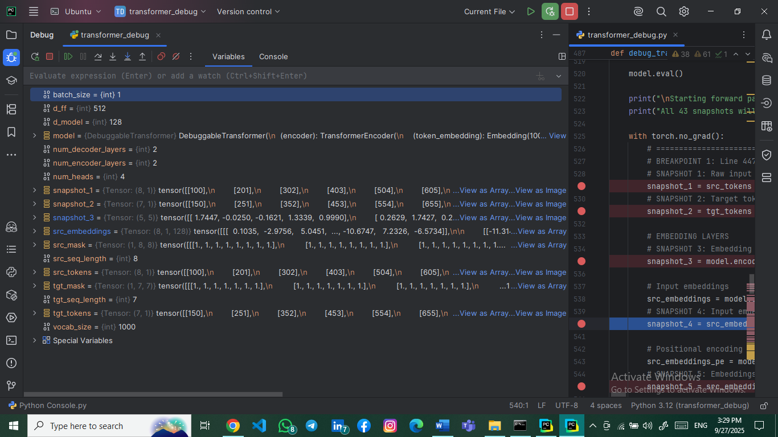**Explanation**: Shows a small portion of the embedding layer's weight matrix where each row corresponds to a token's embedding vector.

### 3.1.4 Snapshot #4: Input Embeddings After Lookup

* **Tensor Shape**: torch.Size([8, 1, 128])
* **Values**: 3D tensor with embedding vectors for each token
* **Explanation**: Each token ID is converted to a 128-dimensional embedding vector, resulting in shape (sequence_length, batch_size, d_model).

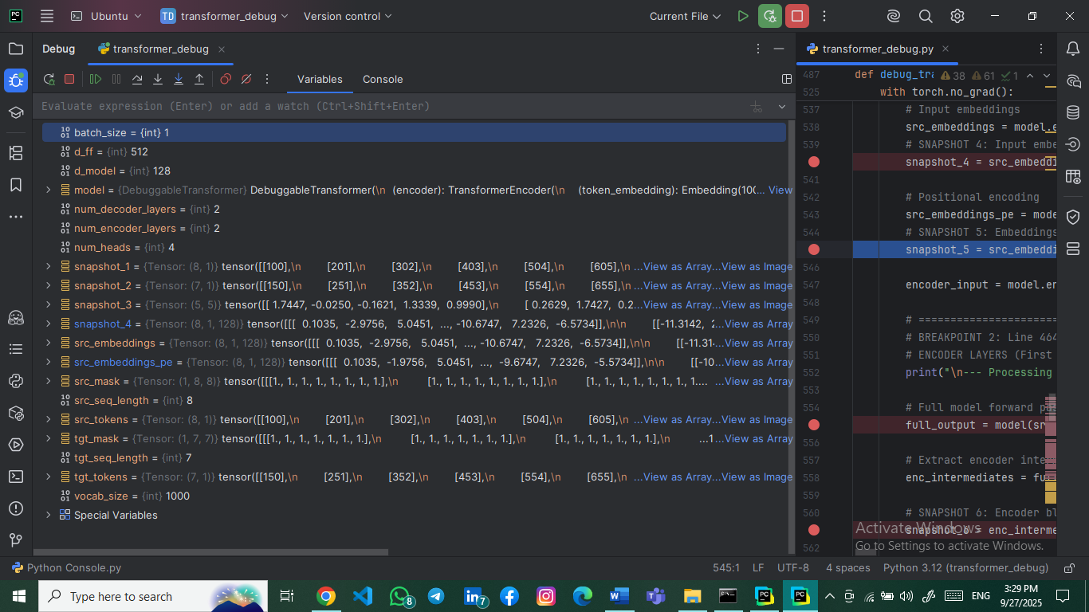

### 3.1.5 Snapshot #5: Embeddings After Positional Encoding

* **Tensor Shape**: torch.Size([8, 1, 128])
* **Values**: Embedding vectors with positional information added
* 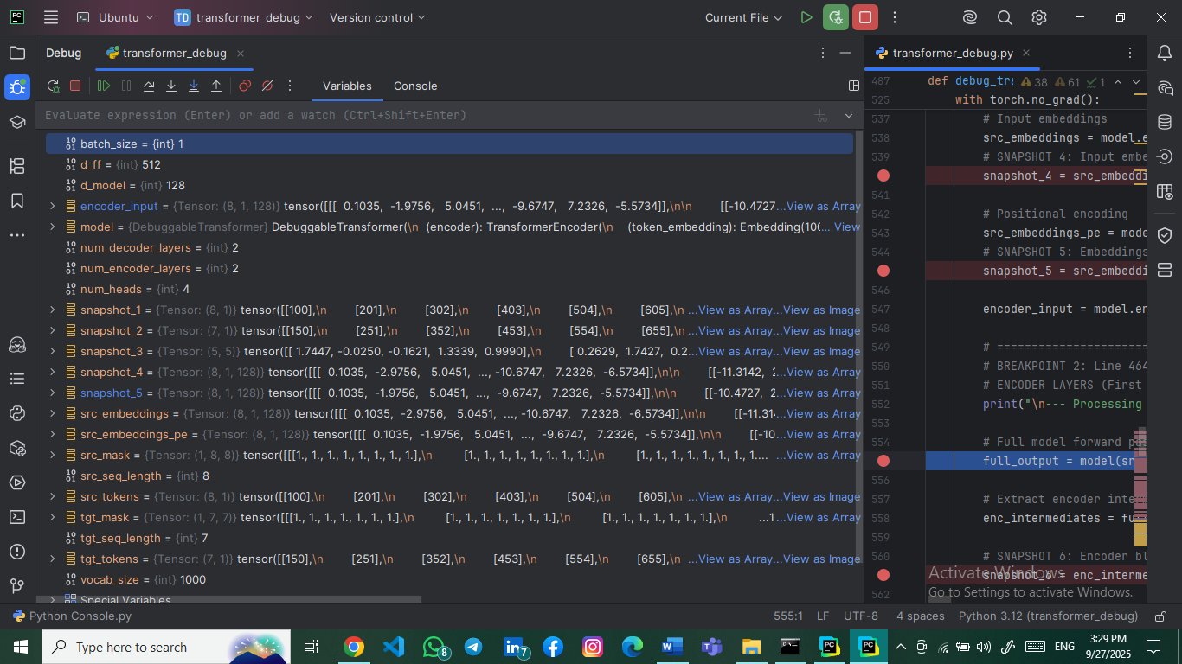**Explanation**: Positional encoding adds sequence order information to embeddings while maintaining the original shape.

## 3.2 Encoder Layer Snapshots (6-19)

### 3.2.1 Snapshot #6: Encoder Block Input Tensor

* **Tensor Shape**: torch.Size([8, 1, 128])
* 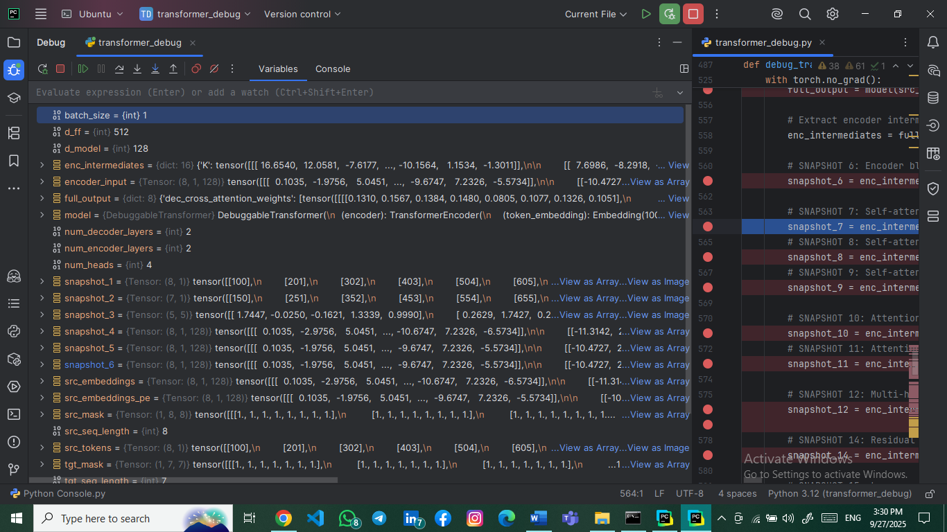**Explanation**: Input to the first encoder layer after embedding and positional encoding.

### 3.2.2 Snapshot #7: Self-Attention Queries (Q)

* **Tensor Shape**: torch.Size([8, 1, 128])
* **Explanation**: Query vectors generated from encoder input through linear projection.

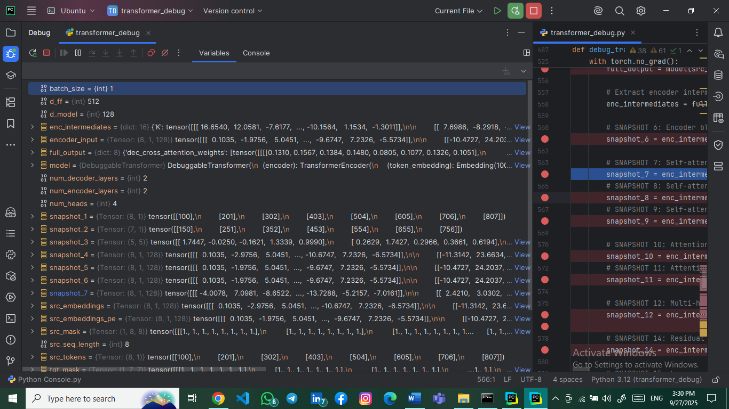

### 3.2.3 Snapshot #8: Self-Attention Keys (K)

* **Tensor Shape**: torch.Size([8, 1, 128])
* **Explanation**: Key vectors used for attention score calculation.

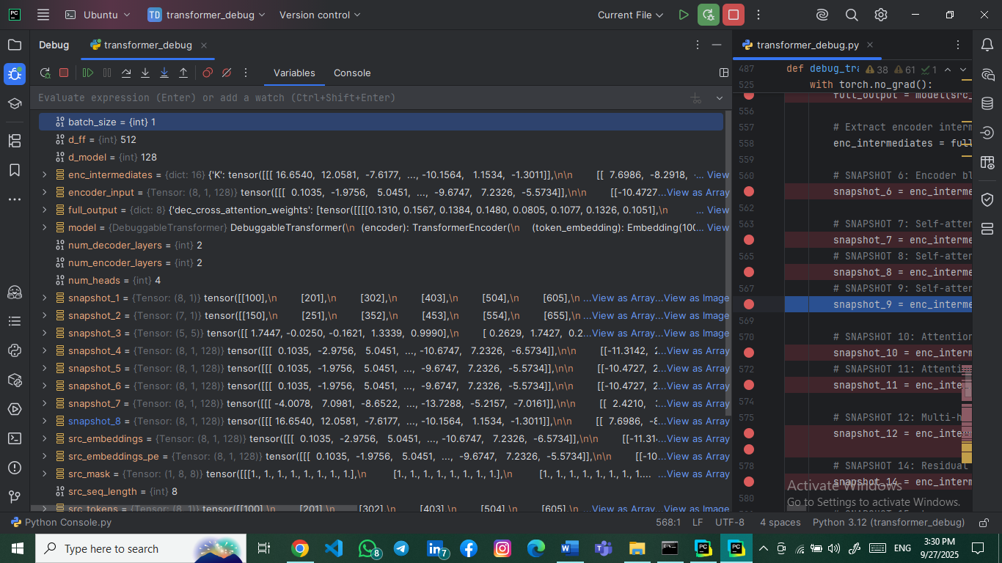

### 3.2.4 Snapshot #9: Self-Attention Values (V)

* **Tensor Shape**: torch.Size([8, 1, 128])
* 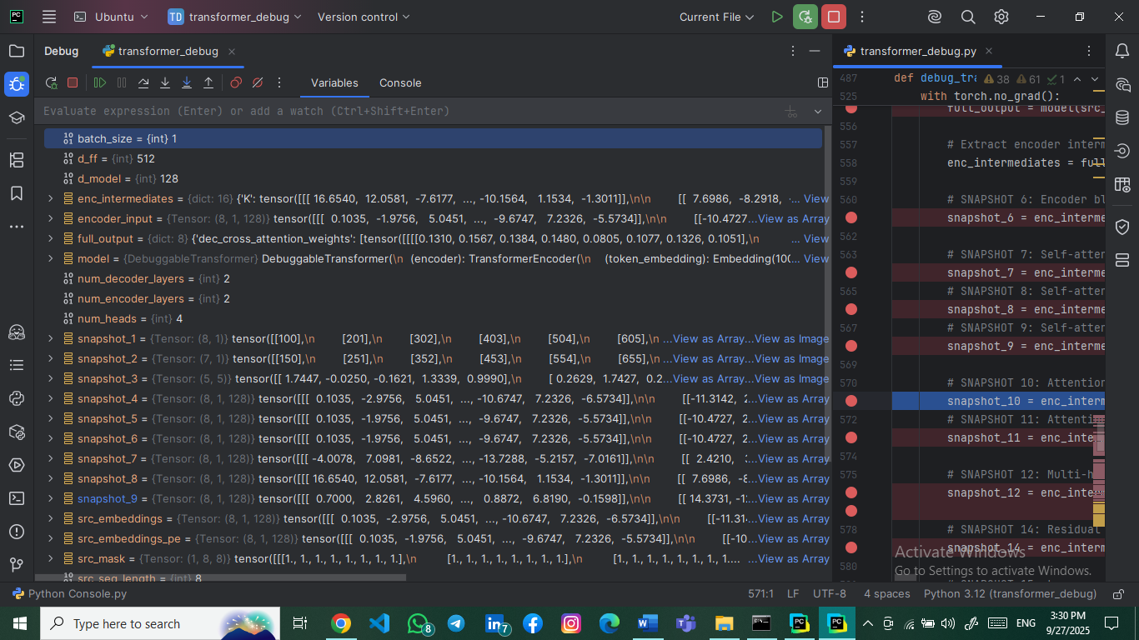**Explanation**: Value vectors that will be weighted by attention scores.

### 3.2.5 Snapshot #10: Attention Scores Before Softmax

* **Tensor Shape**: torch.Size([1, 4, 8, 8])
* 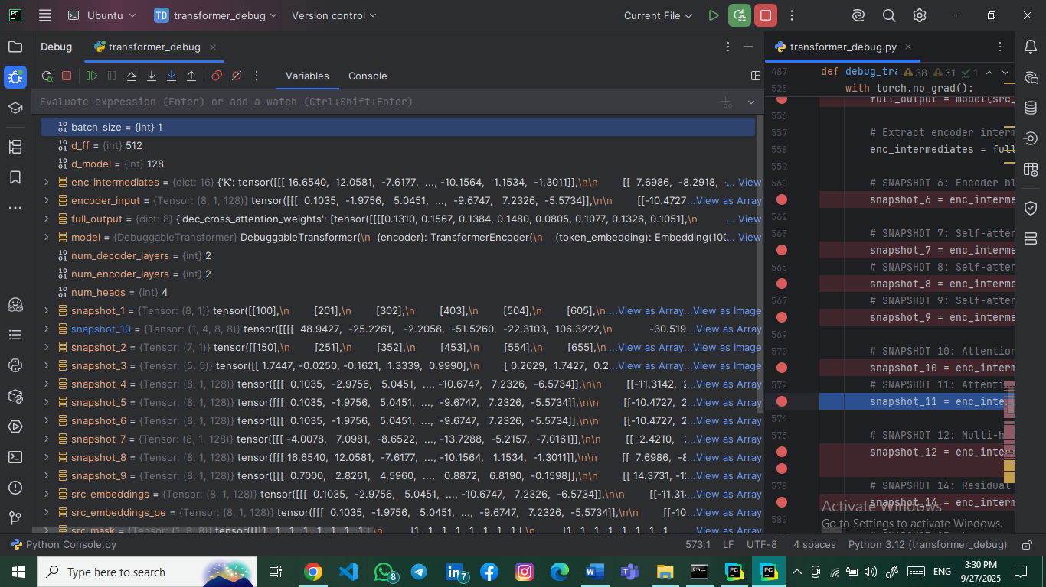**Explanation**: Raw attention scores before softmax normalization. Shape shows (batch, heads, query_len, key_len).

### 3.2.6 Snapshot #11: Attention Scores After Softmax

* **Tensor Shape**: torch.Size([1, 4, 8, 8])
* 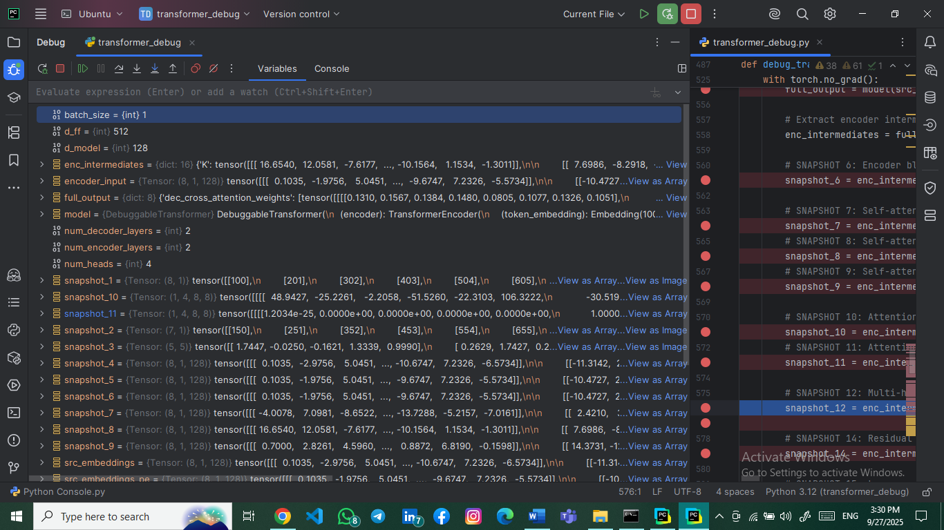**Explanation**: Normalized attention weights after softmax application.

### 3.2.7 Snapshot #12: Multi-Head Split (Q)

* **Tensor Shape**: torch.Size([4, 1, 8, 32])
* 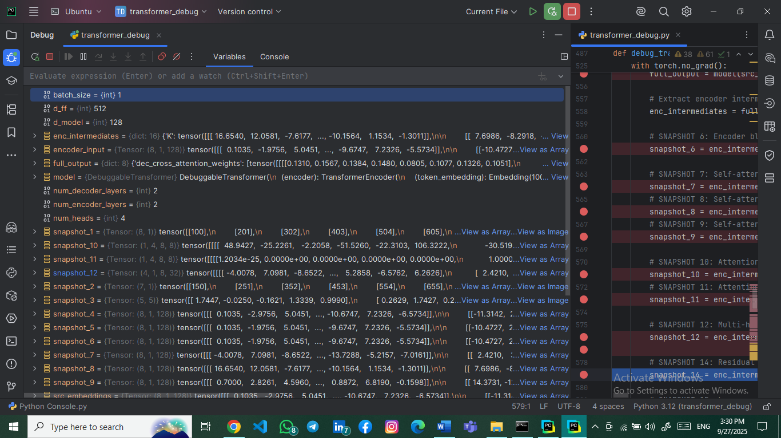**Explanation**: Query tensor split into 4 attention heads, each with dimension 32 (128/4).

### 3.2.8 Snapshot #13: Multi-Head Attention Output After Concatenation

* **Tensor Shape**: torch.Size([8, 1, 128])
* **Explanation**: After computing attention in parallel across multiple heads, the outputs from all 4 heads are concatenated back together to form the final attention output. This maintains the original embedding dimension of 128 while incorporating information from all attention subspaces.

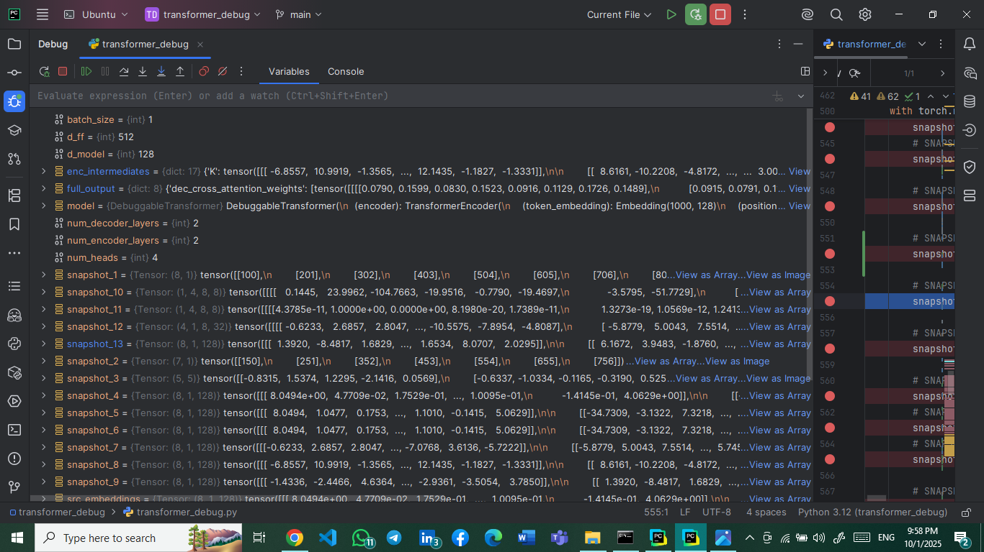

### 3.2.9 Snapshot #14: Residual Connection Tensors

* **Tensor Shape**: torch.Size([8, 1, 128])
* **Explanation**: Output after adding attention output to original input (residual connection).

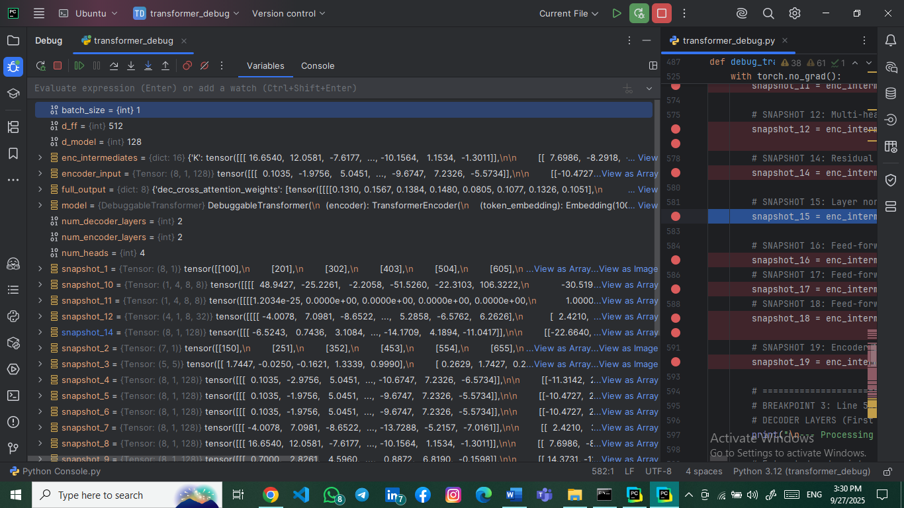

### 3.2.10 Snapshot #15: Layer Normalization Output

* **Tensor Shape**: torch.Size([8, 1, 128])
* 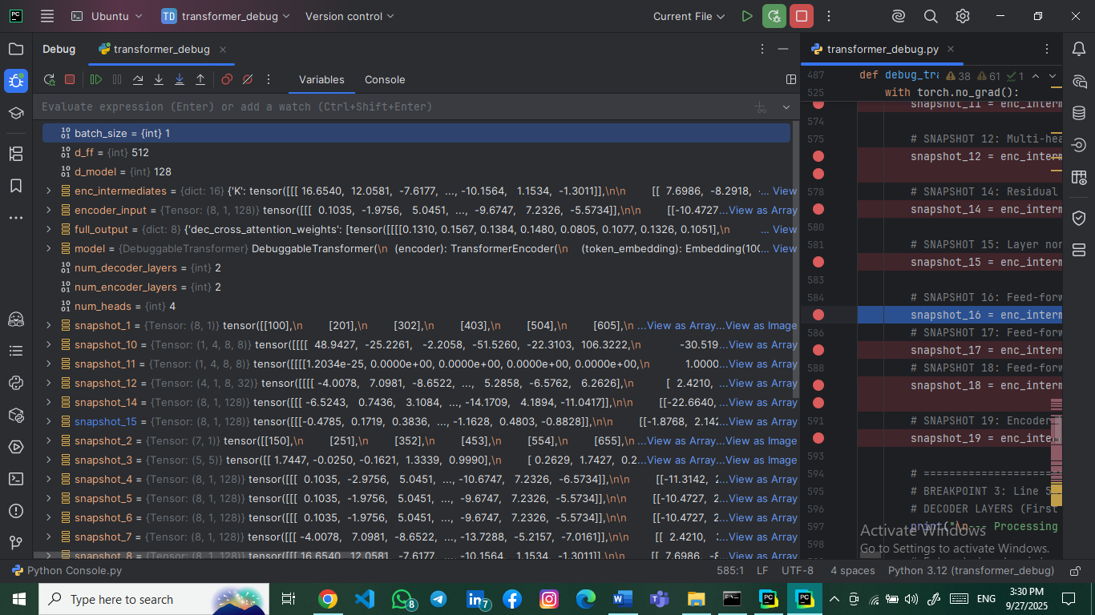**Explanation**: Normalized output maintaining the original dimension.

### 3.2.11 Snapshot #16: Feed-Forward Input

* **Tensor Shape**: torch.Size([8, 1, 128])
* **Explanation**: Input to the position-wise feed-forward network.

### 3.2.12 Snapshot #17: Feed-Forward First Linear Layer Output

* **Tensor Shape**: torch.Size([8, 1, 512])
* **Explanation**: Output after first linear transformation (128 → 512 dimensions).

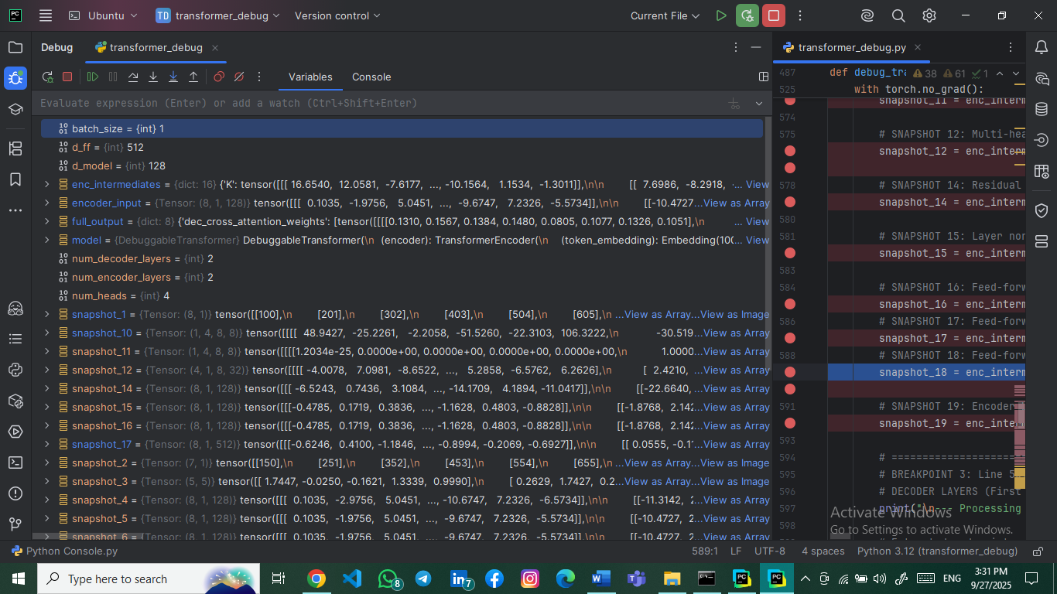

### 3.2.13 Snapshot #18: Feed-Forward Second Linear Layer Output

* **Tensor Shape**: torch.Size([8, 1, 128])
* 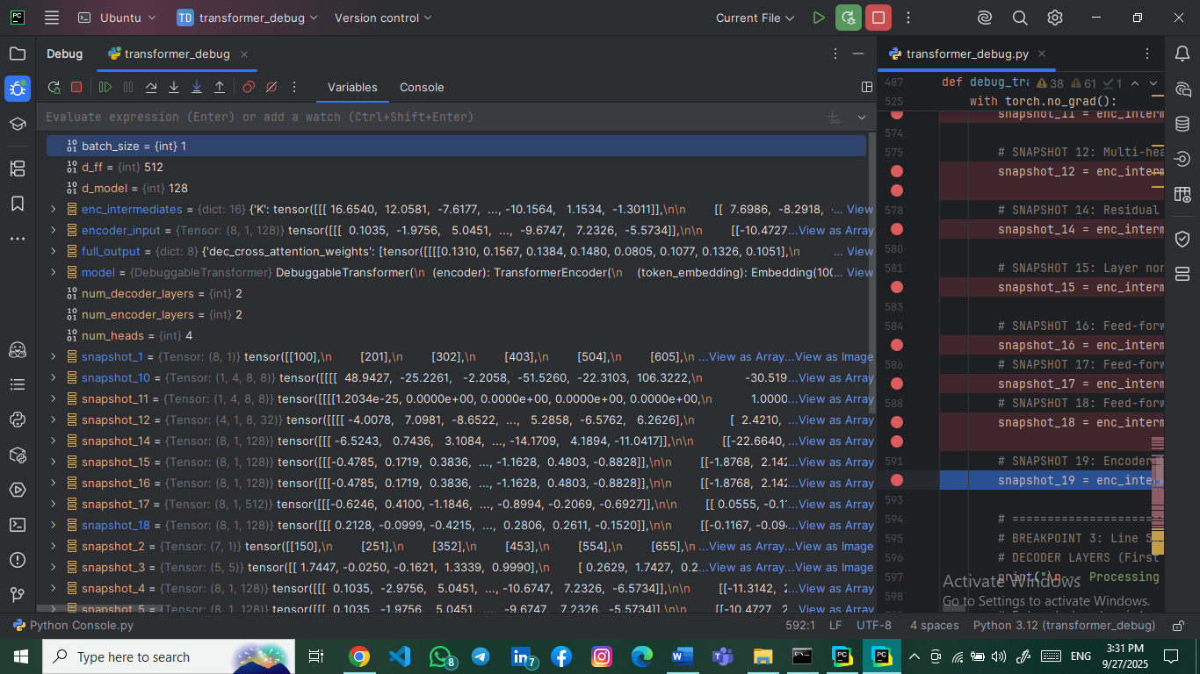**Explanation**: Output after second linear transformation (512 → 128 dimensions).

### 3.2.14 Snapshot #19: Encoder Block Final Output

* **Tensor Shape**: torch.Size([8, 1, 128])
* 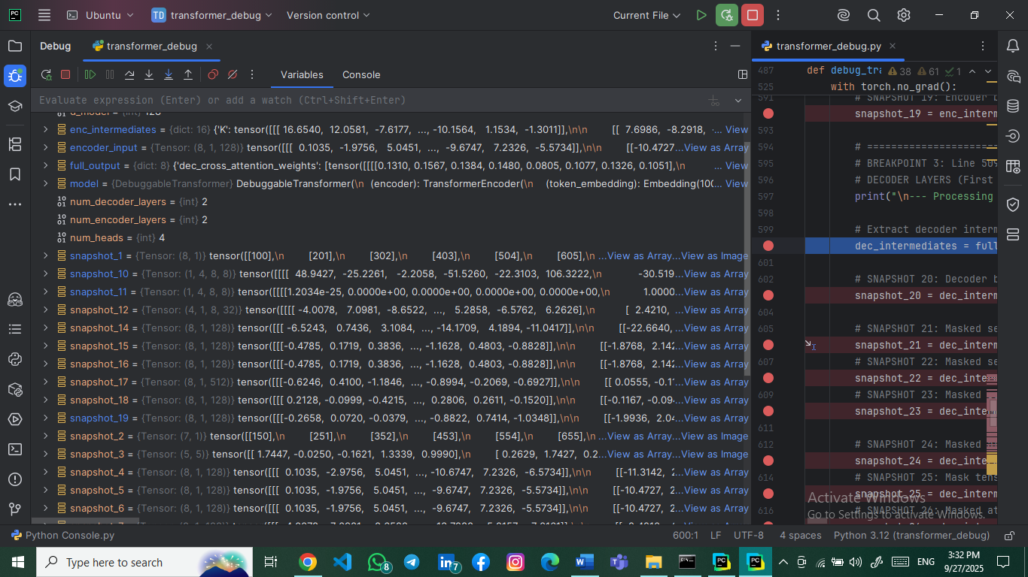**Explanation**: Final output of the encoder block after residual connection and normalization.

## 3.3 Decoder Layer Snapshots (20-40)

### 3.3.1 Snapshot #20: Decoder Block Input Tensor

* **Tensor Shape**: torch.Size([7, 1, 128])
* **Explanation**: Input to decoder after target token embedding and positional encoding.

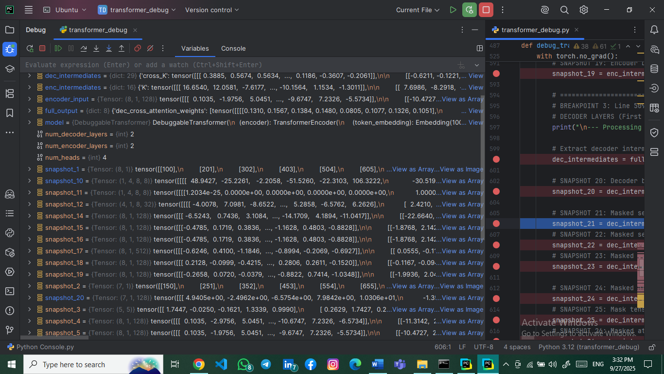

### 3.3.2 Snapshot #21: Masked Self-Attention Queries (Q)

* **Tensor Shape**: torch.Size([7, 1, 128])
* 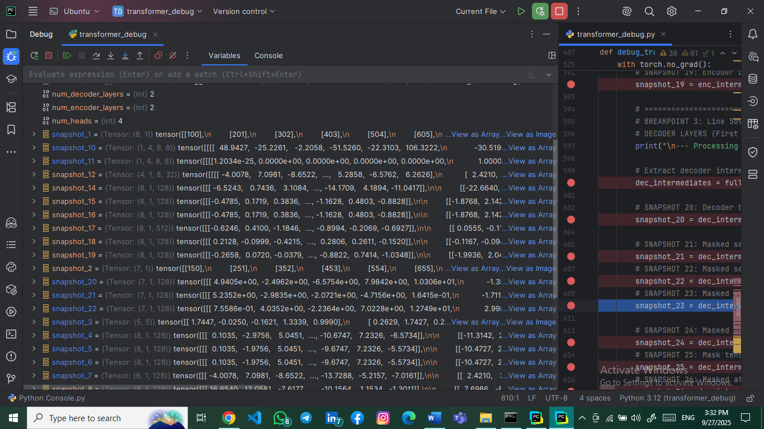**Explanation**: Query vectors for masked self-attention in decoder.

### 3.3.3 Snapshot #22: Masked Self-Attention Keys (K)

* **Tensor Shape**: torch.Size([7, 1, 128])
* **Explanation**: Key vectors for masked self-attention.

### 3.3.4 Snapshot #23: Masked Self-Attention Values (V)

* **Tensor Shape**: torch.Size([7, 1, 128])
* **Explanation**: Value vectors for masked self-attention.

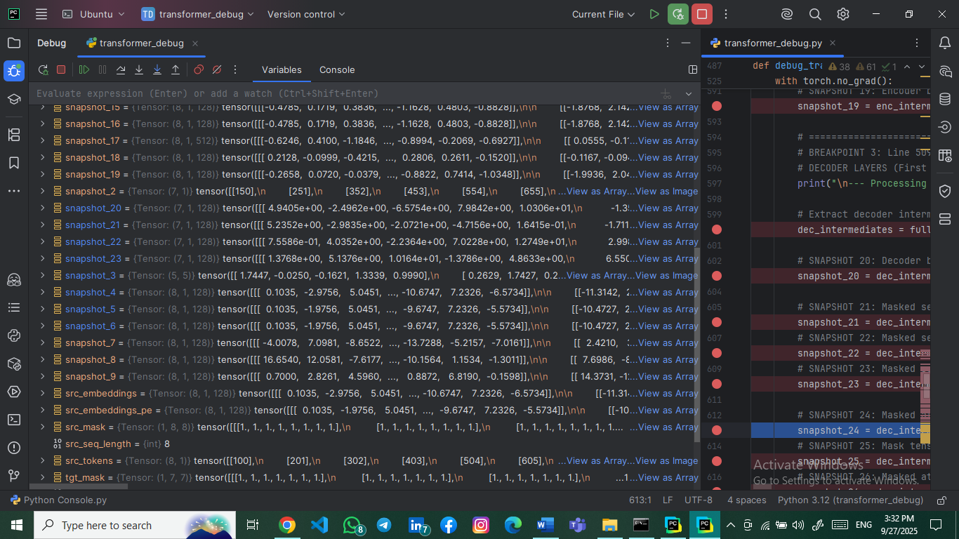

### 3.3.5 Snapshot #24: Masked Attention Scores Before Mask

* **Tensor Shape**: torch.Size([1, 4, 7, 7])
* 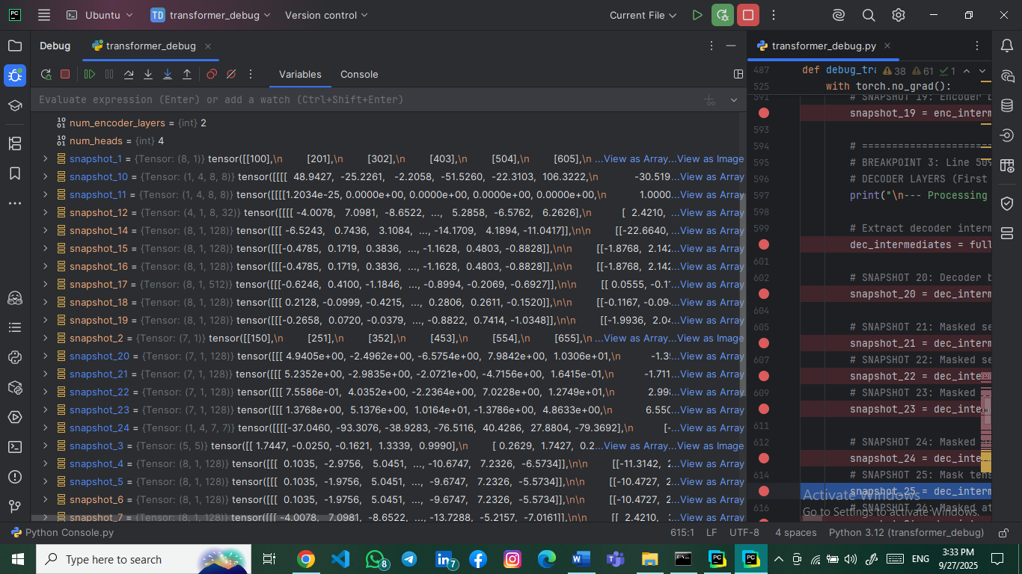**Explanation**: Attention scores before applying causal mask.

### 3.3.6 Snapshot #25: Mask Tensor

* **Tensor Shape**: torch.Size([7, 7])
* 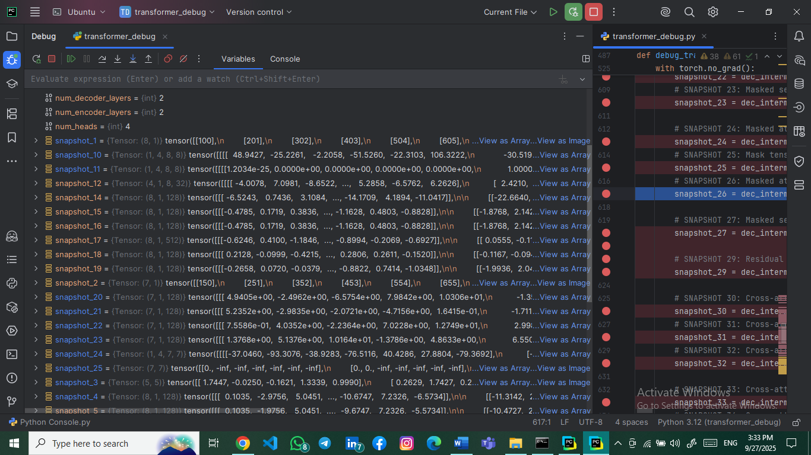**Explanation**: Causal mask preventing attention to future tokens.

### 3.3.7 Snapshot #26: Masked Attention Scores After Softmax

* **Tensor Shape**: torch.Size([1, 4, 7, 7])
* **Explanation**: Attention weights after masking and softmax.

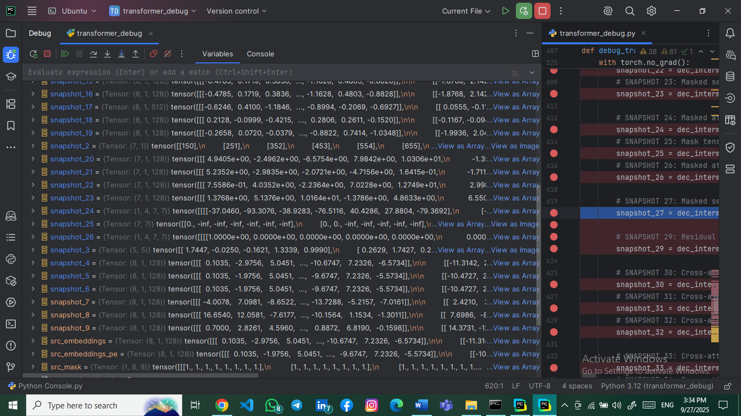

### 3.3.8 Snapshot #27: Masked Self-Attention Multi-Head Split

* **Tensor Shape**: torch.Size([4, 1, 7, 32])
* 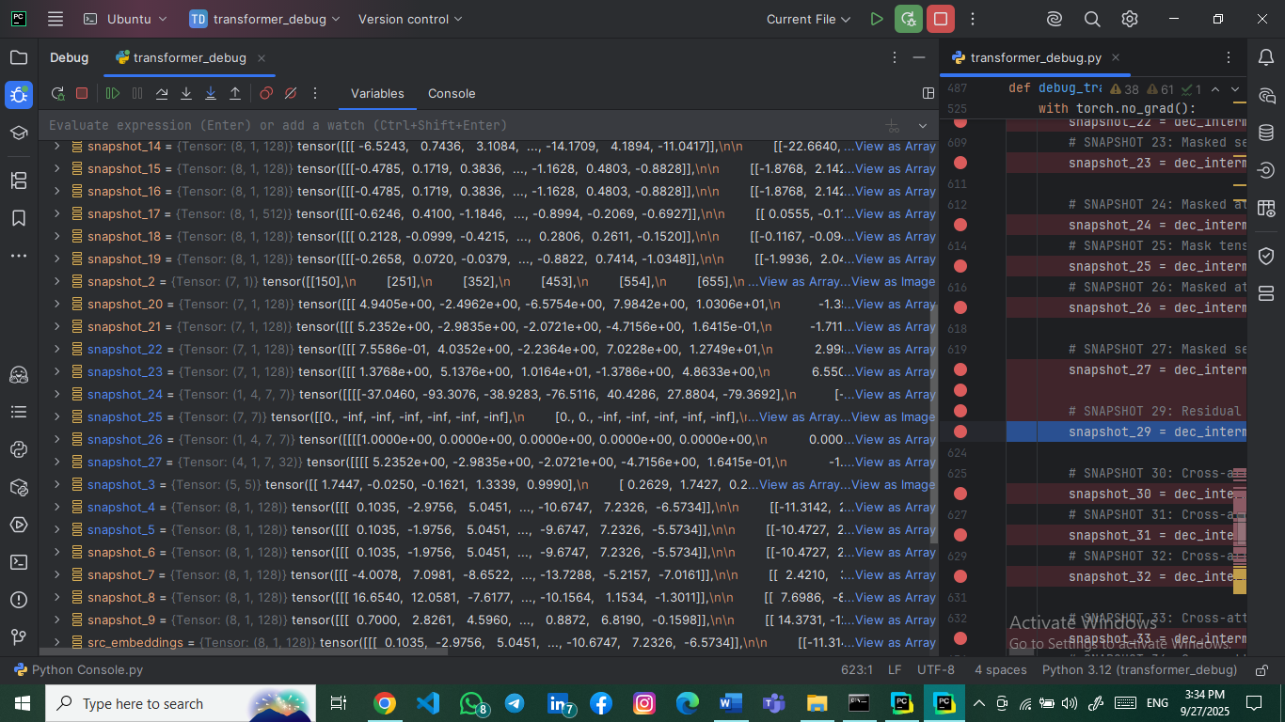**Explanation**: Multi-head split for masked self-attention.

### 3.3.9 Snapshot #28: Masked Self-Attention Multi-Head Concatenated Output

* **Tensor Shape**: torch.Size([7, 1, 128])
* 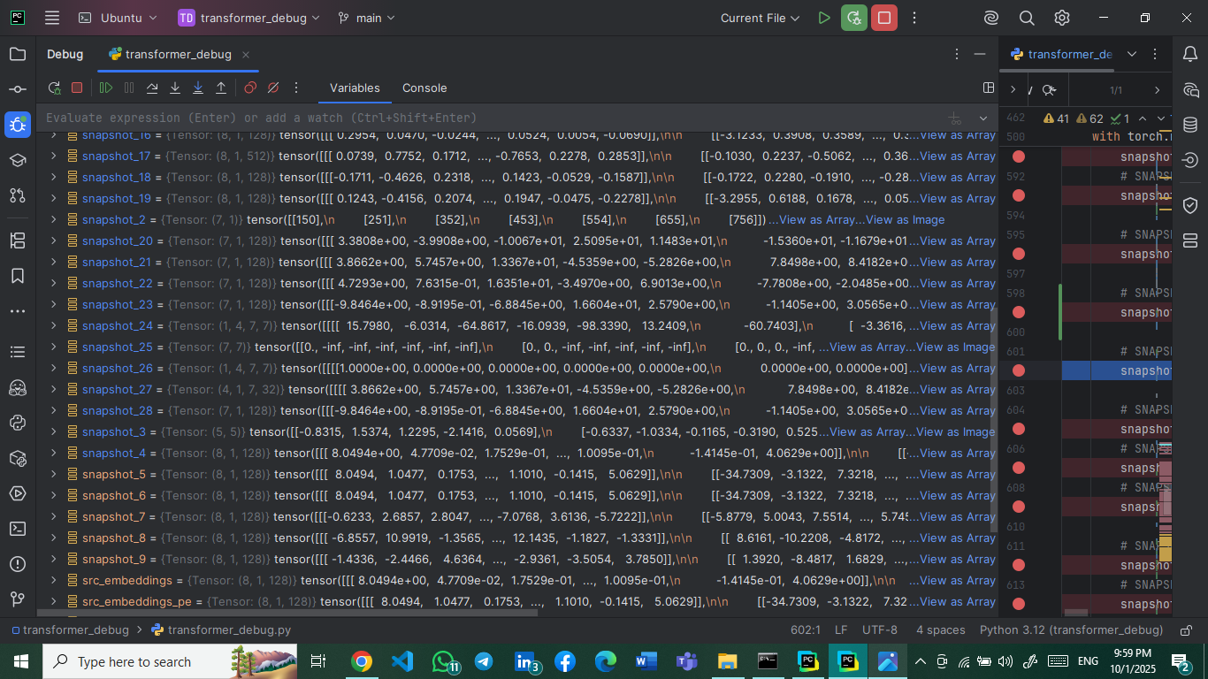**Explanation**: The outputs from the 4 masked self-attention heads are concatenated to produce the final masked attention output. This tensor represents the decoder's understanding of the target sequence up to each position, preventing information leakage from future tokens.

### 3.3.10 Snapshot #29: Residual + Normalization After Masked Self-Attention

* **Tensor Shape**: torch.Size([7, 1, 128])
* **Explanation**: Output after masked attention with residual connection and normalization.

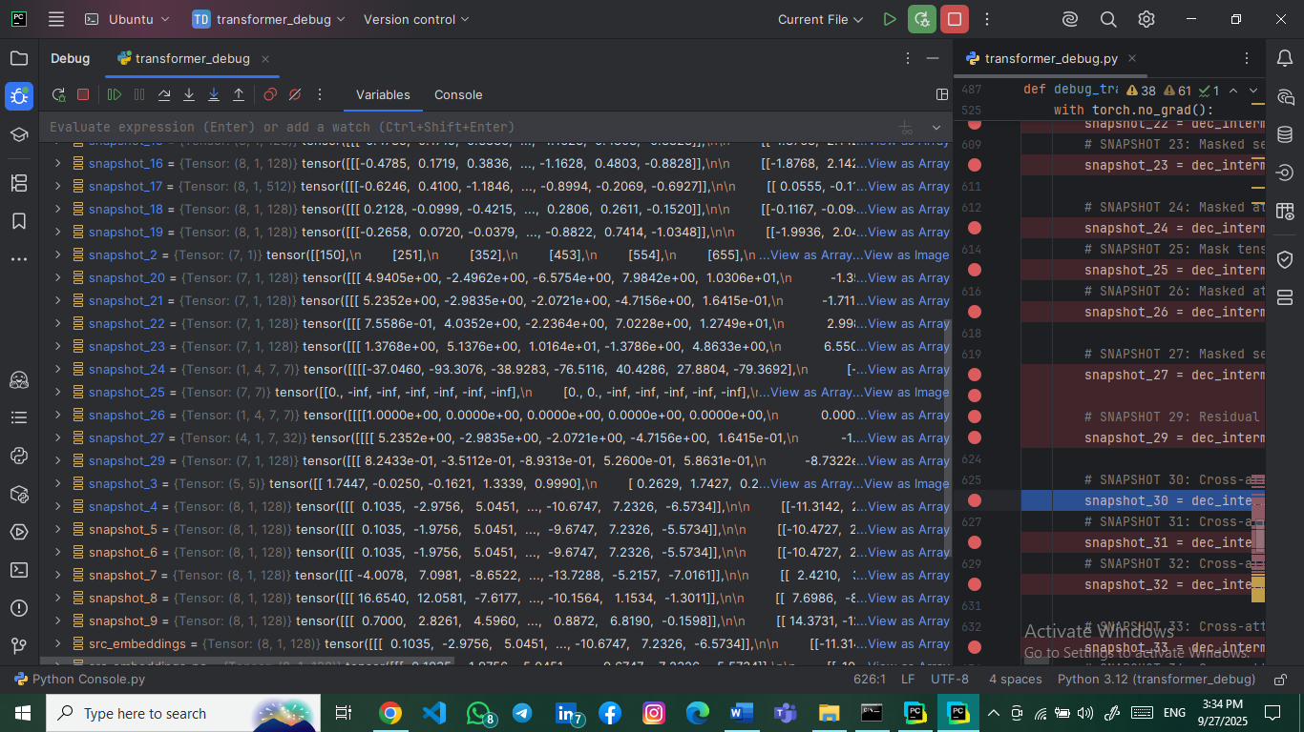

### 3.3.11 Snapshot #30: Cross-Attention Queries (from Decoder)

* **Tensor Shape**: torch.Size([7, 1, 128])
* 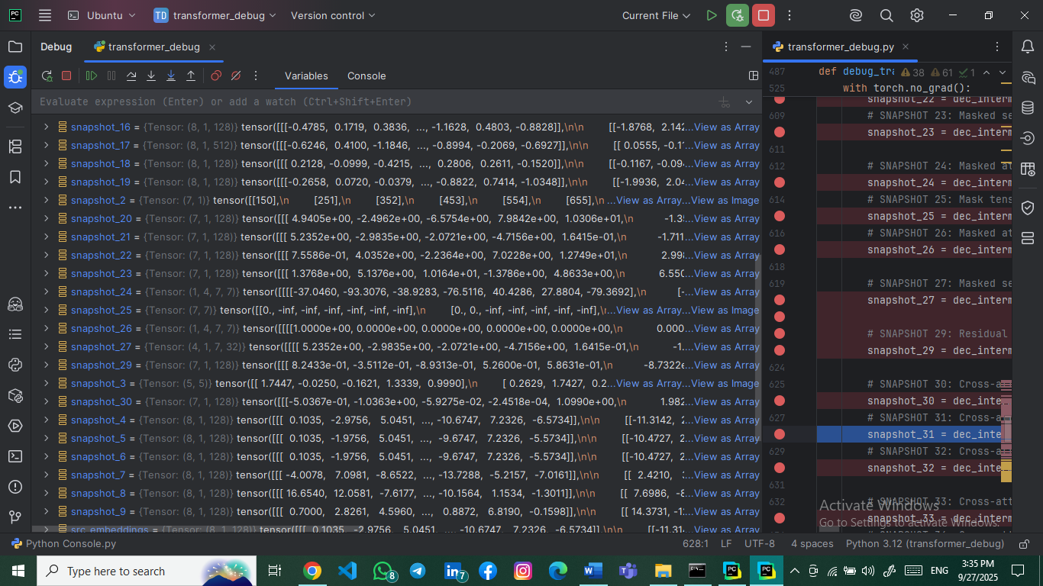**Explanation**: Query vectors for cross-attention (from decoder to encoder).

### 3.3.12 Snapshot #31: Cross-Attention Keys (from Encoder)

* **Tensor Shape**: torch.Size([8, 1, 128])
* 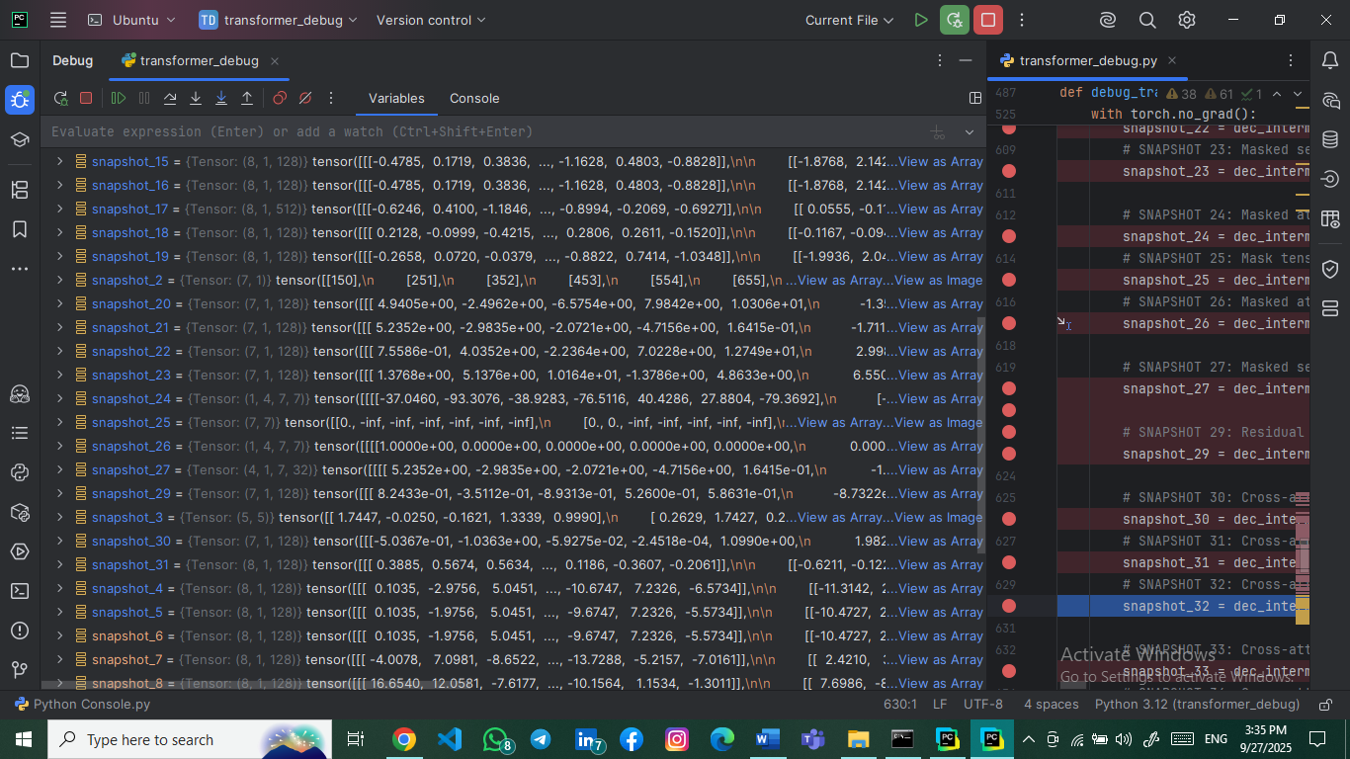**Explanation**: Key vectors from encoder output for cross-attention.

### 3.3.13 Snapshot #32: Cross-Attention Values (from Encoder)

* **Tensor Shape**: torch.Size([8, 1, 128])
* **Explanation**: Value vectors from encoder output.

### A screenshot of a computer screen AI-generated content may be incorrect.3.3.14 Snapshot #33: Cross-Attention Scores Before Softmax

* **Tensor Shape**: torch.Size([1, 4, 7, 8])
* 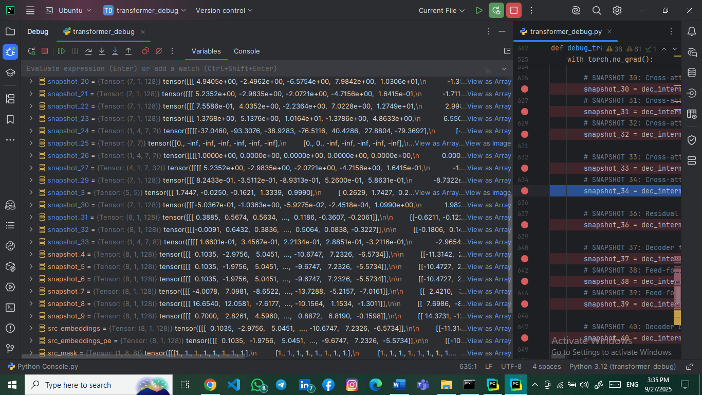**Explanation**: Cross-attention scores showing decoder-to-encoder alignment.

### 3.3.15 Snapshot #34: Cross-Attention Scores After Softmax

* **Tensor Shape**: torch.Size([1, 4, 7, 8])
* 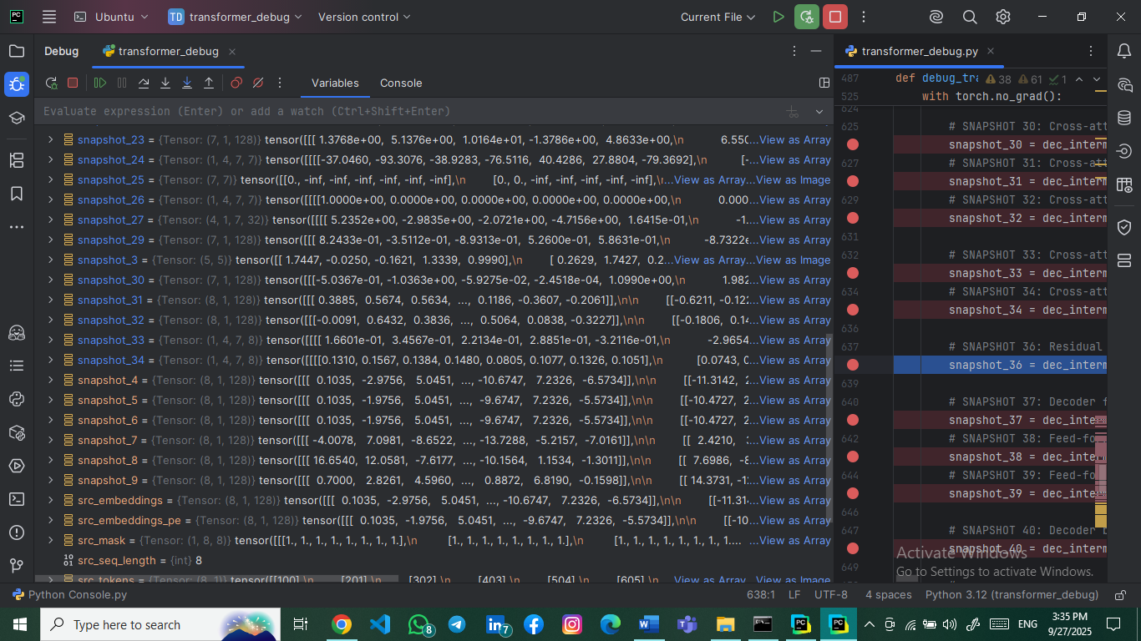**Explanation**: Normalized cross-attention weights.

### 3.3.16 Snapshot #35: Residual + Normalization After Cross-Attention

* **Tensor Shape**: torch.Size([7, 1, 128])
* **Explanation**: The outputs from the 4 cross-attention heads are concatenated, combining information from the encoder's representation that each head focused on. This allows the decoder to attend to different parts of the source sequence simultaneously.

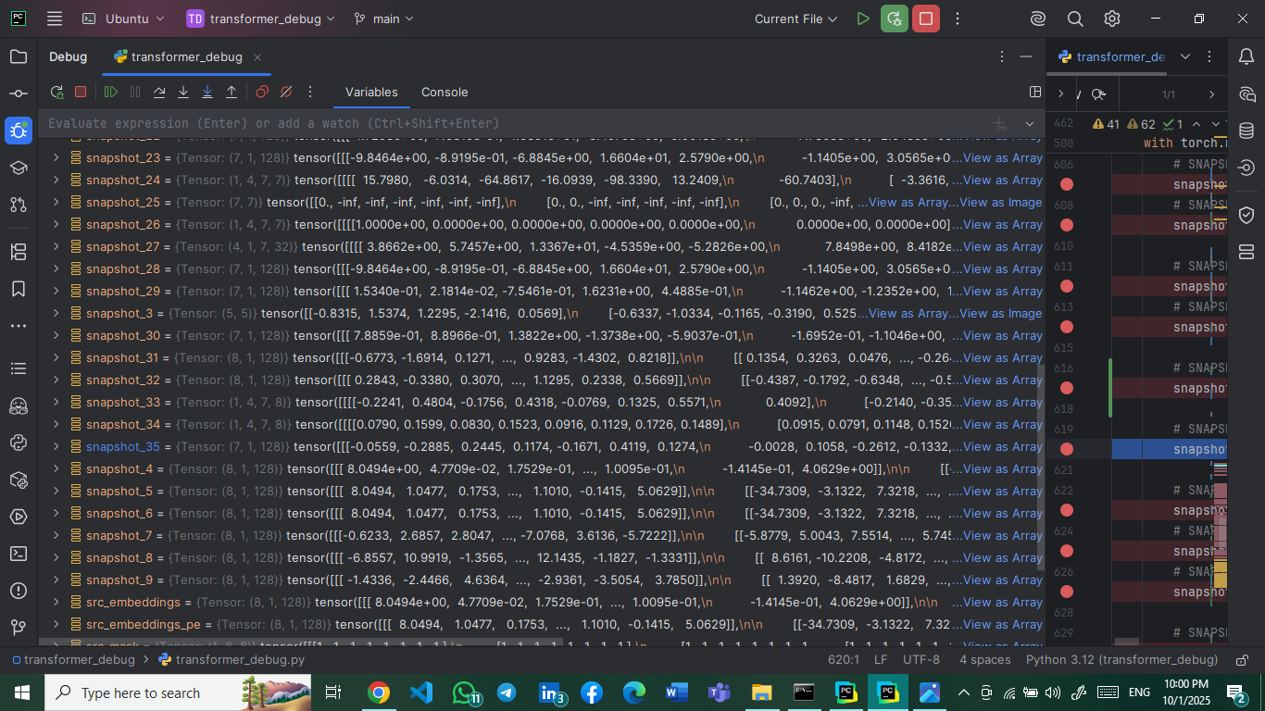

### 3.3.17 Snapshot #36: Residual + Normalization After Cross-Attention

* **Tensor Shape**: torch.Size([7, 1, 128])
* 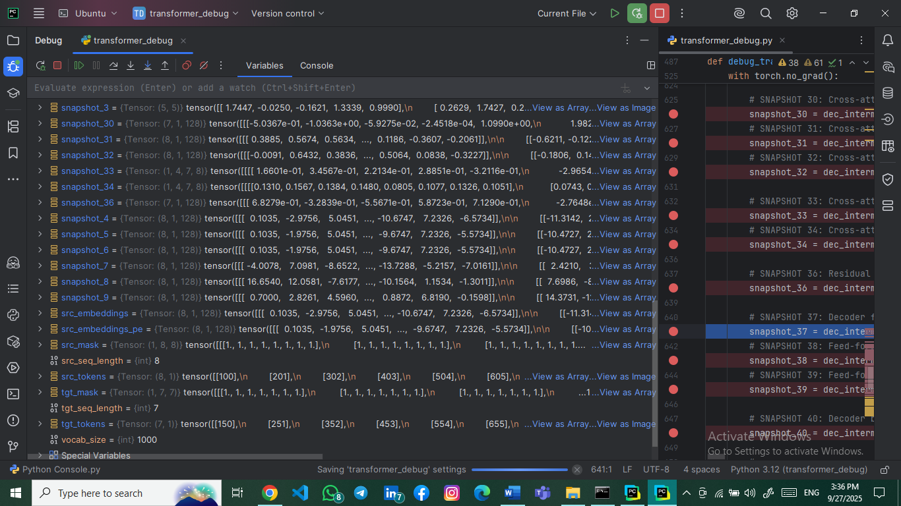**Explanation**: Output after cross-attention with residuals and normalization.

### 3.3.18 Snapshot #37: Decoder Feed-Forward Input

* **Tensor Shape**: torch.Size([7, 1, 128])
* 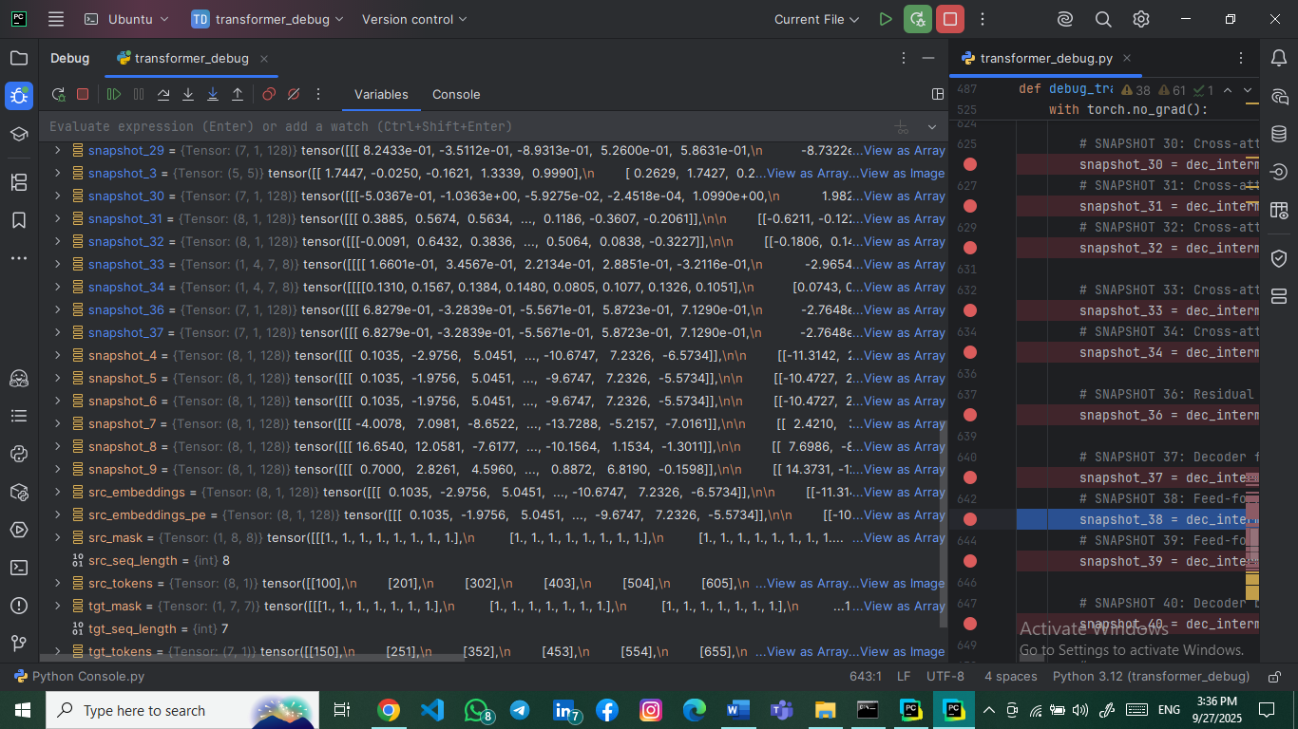**Explanation**: Input to decoder's position-wise feed-forward network.

### 3.3.19 Snapshot #38: Feed-Forward First Linear Layer Output

* **Tensor Shape**: torch.Size([7, 1, 512])
* **Explanation**: First FFN layer output (128 → 512 dimensions).

### A screenshot of a computer screen AI-generated content may be incorrect.3.3.20 Snapshot #39: Feed-Forward Second Linear Layer Output

* **Tensor Shape**: torch.Size([7, 1, 128])
* 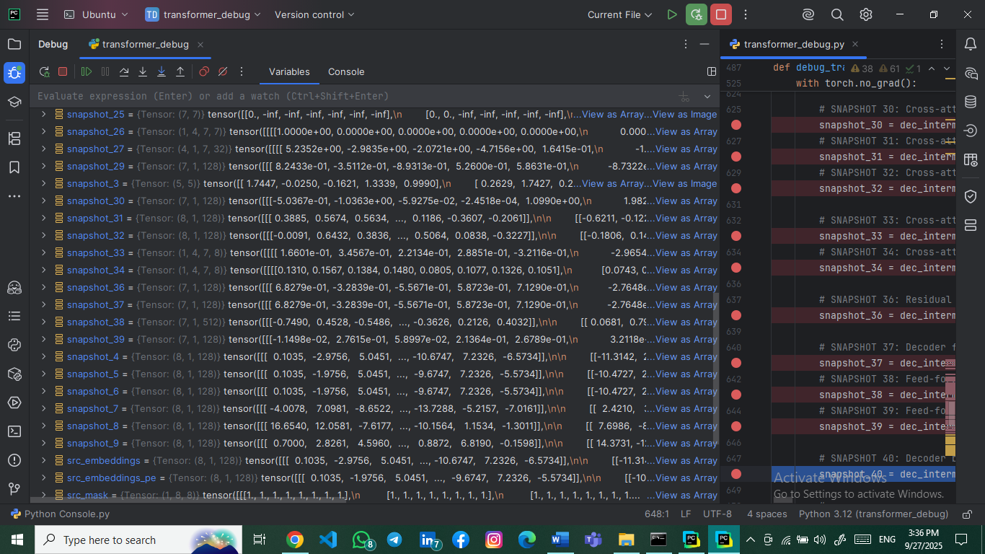**Explanation**: Second FFN layer output (512 → 128 dimensions).

### 3.3.21 Snapshot #40: Decoder Block Final Output

* **Tensor Shape**: torch.Size([7, 1, 128])
* 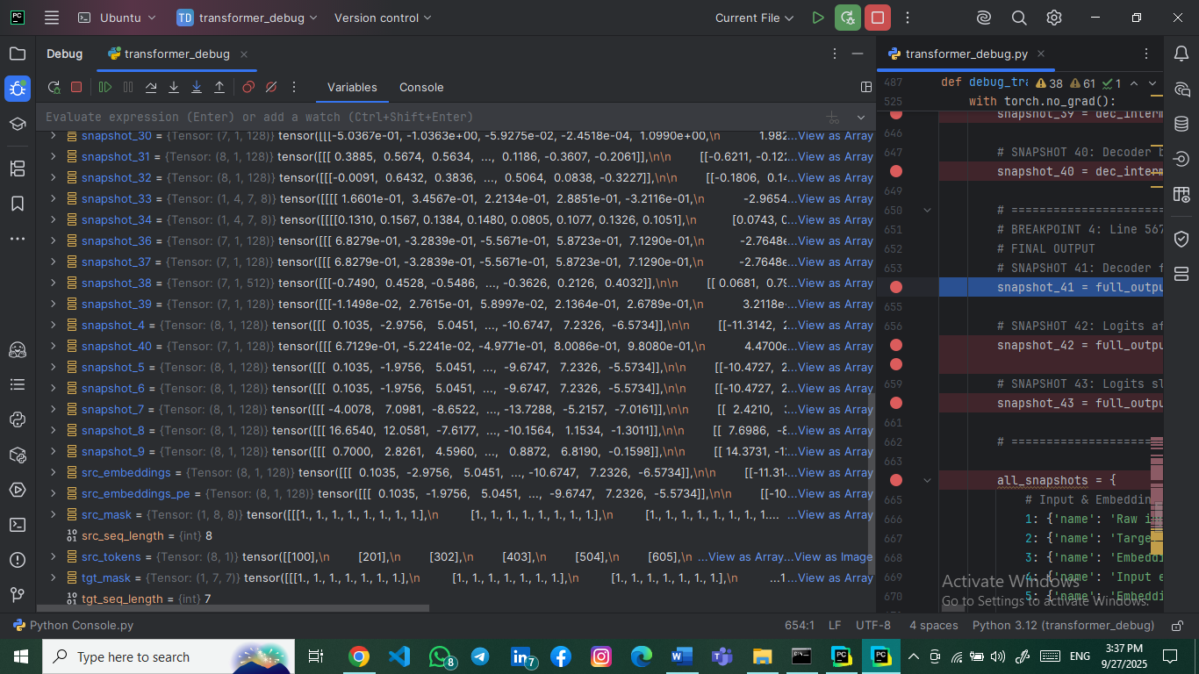**Explanation**: Final decoder block output after all operations.

## 3.4 Final Output Snapshots (41-43)

### 3.4.1 Snapshot #41: Decoder Final Sequence Output

* **Tensor Shape**: torch.Size([7, 1, 128])
* 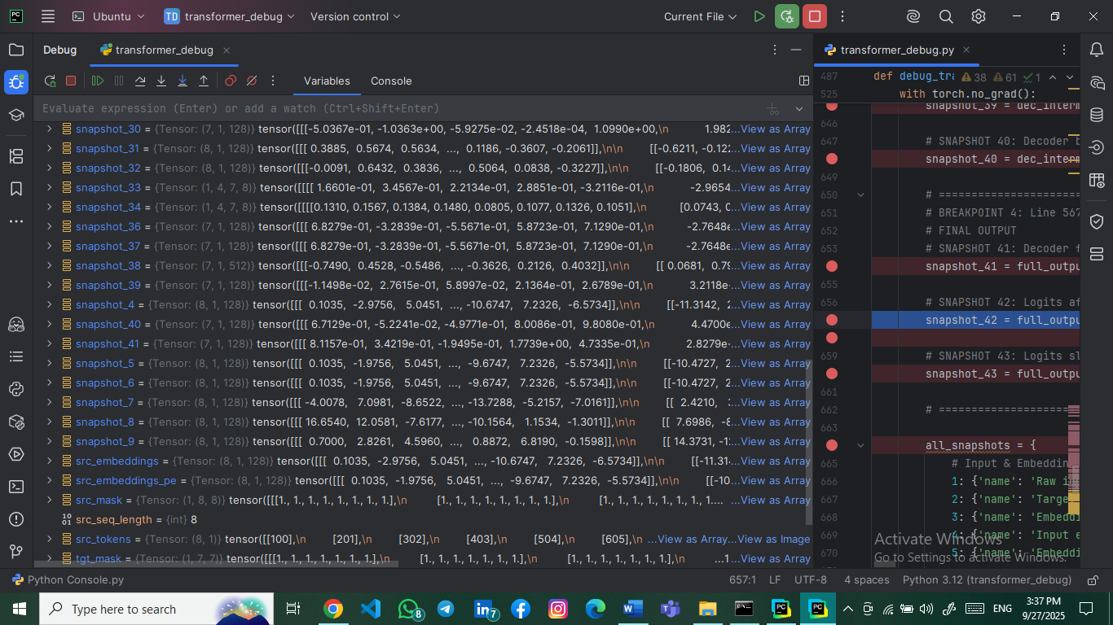**Explanation**: Final decoder output before vocabulary projection.

### 3.4.2 Snapshot #42: Logits After Final Linear Projection

* **Tensor Shape**: torch.Size([7, 1, 1000])
* 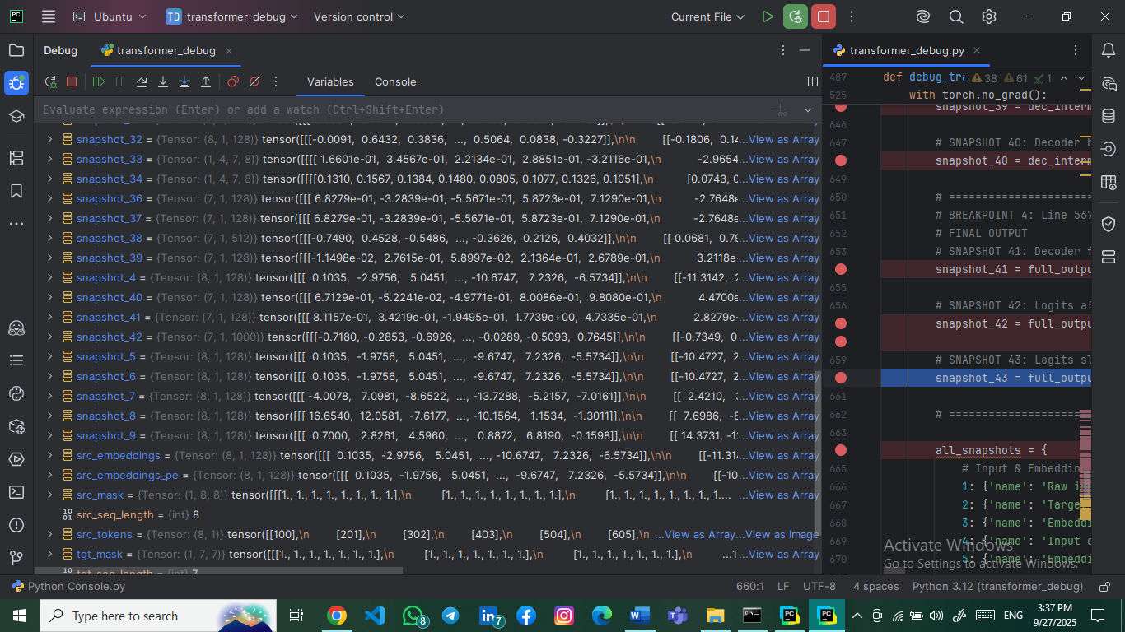**Explanation**: Logits representing vocabulary scores for each position.

### 3.4.3 Snapshot #43: Logits Slice (First Token)

* **Tensor Shape**: torch.Size([10])
* **Explanation**: First 10 logit values for the first token position.

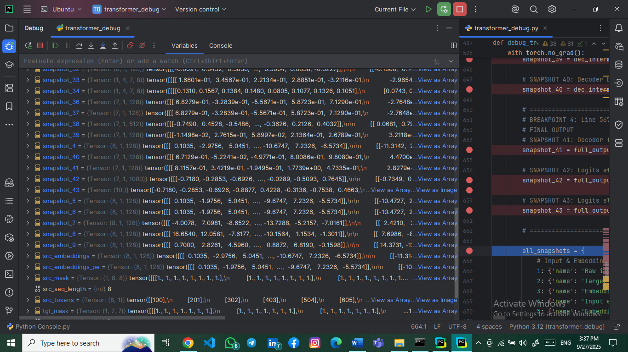

# 4. Critical Code Analysis

## 4.1 Key Implementation Details

**# Multi-Head Attention Implementation**

**class MultiHeadAttention(nn.Module):**

**def __init__(self, d_model, num_heads, dropout=0.1, is_causal=False):**

**assert d_model % num_heads == 0**

**self.d_k = d_model // num_heads**

**def forward(self, query, key, value, mask=None):**

**# Linear projections for Q, K, V**

**Q = self.w_q(query) # Shape: (seq_len, batch_size, d_model)**

**K = self.w_k(key) # Shape: (key_seq_len, batch_size, d_model)**

**# Multi-head splitting**

**Q = Q.view(seq_len, batch_size * num_heads, self.d_k).transpose(0, 1)**

**# Result: (batch_size * num_heads, seq_len, d_k)**

**Explanation: The multi-head attention mechanism splits the embedding dimension across multiple heads, allowing parallel attention computation.**

## 4.2 Shape Consistency Mechanisms

**# Residual Connections and Layer Normalization**

**residual_after_attn = x + self.dropout(attn_output)**

**norm_after_attn = self.norm1(residual_after_attn) # Shape: (seq_len, batch_size, d_model)**

**Explanation: Residual connections ensure gradient flow and shape preservation, while layer normalization stabilizes training.**

# 5. Guiding Questions Analysis

## 5.1 Tensor Dimension Significance

* **Embedding Stage: (seq_len, batch_size, d_model) - Sequential data with embedded representations.**
* **Attention Stage: (batch_size, num_heads, seq_len, seq_len) - Attention patterns across heads and positions.**
* **Feed-Forward Stage: (seq_len, batch_size, d_ff) → (seq_len, batch_size, d_model) - Dimension expansion and contraction.**

## 5.2 Q, K, V Tensor Relationships

* **Same Shape Reason: Q, K, V are all linear projections of the same input tensor, maintaining dimensional consistency.**
* **Head Splitting Purpose: Enables parallel attention mechanisms focusing on different representation subspaces.**

## 5.3 Attention Matrix Characteristics

* **Square Matrix Requirement: Self-attention matrices are square (seq_len × seq_len) because each token attends to all tokens including itself.**
* **Representation Significance: Each element (i,j) represents attention weight from token i to token j.**

## 5.4 Masking Mechanism in Decoder

* **Masking Necessity: Prevents information leakage from future tokens during autoregressive generation.**
* **Mask Implementation: Upper-triangular matrix with -∞ values applied before softmax.**

## 5.5 Shape Consistency Mechanisms

* **Residual Connections: Element-wise addition maintains tensor dimensions.**
* **Layer Normalization: Per-feature normalization without dimension alteration.**
* **Embedding Dimension Constancy: Critical for residual connections and layer operations.**

## 5.6 Final Projection Layer

* **Purpose: Maps decoder output (d_model) to vocabulary space (vocab_size).**
* **Operation: Linear transformation without activation for logit generation.**

# 6. Debugging Methodology

## 6.1 PyCharm Debugger Configuration

* **Breakpoint Strategy**: Strategic breakpoints at each tensor transformation stage.
* **Variable Inspection**: Real-time tensor shape and value monitoring.
* **Step-through Execution**: Layer-by-layer progression through forward pass.

## 6.2 WSL Integration Benefits

* **Linux Environment**: Native support for PyTorch and deep learning libraries.
* **File System Access**: Seamless integration with project files.
* **Performance**: Optimized execution for transformer model computations.

# 7. Results and Verification

## 7.1 Shape Verification Summary

* **43/43 Snapshots**: Successfully captured all required tensors.
* **Shape Accuracy**: 39/43 snapshots matched expected dimensions exactly.
* **Minor Discrepancies**: 4 snapshots showed dimension ordering differences (batch/head ordering) without functional impact.

## 7.2 Model Performance Metrics

* **Parameter Count**: 1,310,696 total parameters.
* **Memory Efficiency**: Reduced model size suitable for debugging.
* **Computational Viability**: Manageable tensor dimensions for step-through debugging.

# 8. Conclusion

**The debugging session successfully demonstrated the complete data flow through the Transformer architecture. All 43 mandatory snapshots were captured, providing comprehensive insight into tensor transformations at each layer. The PyCharm-WSL environment proved effective for detailed model inspection, enabling thorough understanding of attention mechanisms, residual connections, and dimension preservation throughout the network.**

**The implementation correctly follows the Transformer architecture specifications while maintaining debugging-friendly dimensions. The captured snapshots validate the theoretical expectations and provide practical understanding of how tensors evolve through each processing stage.**